A TECHNICAL SEMINAR REPORT ON

**MOBILE CLOUD COMPUTING**

*Submitted in partial fulfilment of requirement for the award of the degree of*

**BACHELOR OF TECHNOLOGY**

*In*

**COMPUTER SCIENCE AND ENGINEERING**

**

*Submitted by*

**CHEVULA BHAVANI**

**19BD1A0568**

**DEPARTMENT OF COMPUTER SCIENCE AND ENGINEERING**

**KESHAV MEMORIAL INSTITUTE OF TECHNOLOGY**

**(Approved by AICTE, Affiliated to JNTUH)**

**Narayanaguda, Hyderabad, Telangana-29 2022-23**

**CERTIFICATE**

This is to certified that seminar work entitled “**MOBILE CLOUD COMPUTING**” is a

bonafide work carried out in the seventh semester by “**CHEVULA BHAVANI 19BD1A0568**” in

partial fulfilment for the award of Bachelor of Technology in “**COMPUTER SCIENCE &**

**ENGINEERING**” from JNTU Hyderabad during the academic year 2022 – 2023 and no part of this

work has been submitted earlier for the award of any degree.

TS INCHARGE INTERNAL EXAMINER

HEAD OF THE DEPARTMENT

**KESHAV MEMORIAL INSTITUTE OF TECHNOLOGY**

**(Accredited by NBA & NAAC, Approved By A.I.C.T.E., Reg by Govt of**

**Telangana State & Affiliated to JNTU, Hyderabad)**

**INDEX**

**Table of Contents PAGE NO.**

**1. Abstract 4**

**2. List of figures 5**

**3. Introduction 6**

**4. Mobile computing 6**

**5. Cloud computing 7**

**6. Mobile Cloud Computing 10**

**7. Cloud App 11**

**8. The Advantages of Mobile Cloud Computing 14**

**9. Challenges in Mobile Cloud Computing 14**

**10. Applications of Mobile Cloud Computing (Real World Examples) 15**

**11. The Future of Mobile Cloud Computing 17**

**12. Research Areas in Mobile Cloud Computing 18**

**13. Conclusion 19**

**14. References 19**

**KESHAV MEMORIAL INSTITUTE OF TECHNOLOGY**

**(Accredited by NBA & NAAC, Approved By A.I.C.T.E., Reg by Govt of**

**Telangana State & Affiliated to JNTU, Hyderabad)**

**ABSTRACT**

In recent years, mobile devices have become popular for communication and running advanced real-time applications such as face recognition and online games. Although mobile devices have advanced to provide significant benefits for mobile users, they still suffer from limited resources such as computation power, battery life and storage space due to their portability. However, cloud computing technology overcomes the limitations of mobile computing with better performance and resources. Cloud technology provides enough computing resources to run mobile applications as storage and computing power on cloud platforms. Therefore, the novel technology called Mobile Cloud Computing (MCC) was introduced by integrating two technologies (mobile computing and cloud computing) in order to overcome the limitations of mobile devices. After doing a sufficient amount of research, I have noticed that mobile devices do not need to have a powerful configuration because all computations can be performed outside the mobile devices. This technical seminar gives a summary of MCC, which includes an introduction, architecture, applications, and benefits of MCC. It also covers the issues and approaches for MCC and future research directions in Mobile Cloud Computing.

 **KESHAV MEMORIAL INSTITUTE OF TECHNOLOGY**

**(Accredited by NBA & NAAC, Approved By A.I.C.T.E., Reg by Govt of**

**Telangana State & Affiliated to JNTU, Hyderabad)**

**List of figures Page no.**

**1. Cloud Computing 7**

**2. Cloud computing architecture 8**

**3. Architecture of MCC 10**

**4.Applications of MCC 15**

**5. Mobile cloud forecast period from 2022-27 18**

**Introduction**

Everyone who has a smartphone uses mobile apps. Love them or hate them, mobile apps are here to stay, and it seems they are only getting stronger as multiple new apps are added to the app stores. It is interesting to note that though the number of new apps in the market is increasing, the number of app downloads is still increasing at a massive proportion. *According to Statista*, 5 million+ apps were built with different technologies and in different ways. Yes, until recently, native app development was the standard, which had to be downloaded and installed on the devices before they could be used. Another thing about native apps is that you need to develop separate apps for separate platforms like iOS and Android.

The rapid progress of mobile computing (MC) has become a powerful trend in the development of IT technology as well as commerce and industry fields. However, mobile devices are facing many challenges in terms of their resources (e.g., battery life, storage, and bandwidth) and communications (e.g., mobility and security). The limited resources significantly impede the improvement of service quality. On the other hand, advances in the field of network-based computing and applications on demand have led to an explosive growth of application models such as cloud computing, software as a service, community network, web store, and so on. As a major application model in the era of the Internet, the term "Cloud Computing" has become a significant research topic in the scientific and industrial communities since 2007. Commonly, cloud computing is described as a range of services that are provided by an Internet-based cluster system. Such cluster systems consist of a group of low-cost servers or personal computers (PCs), organizing the various resources of the computers according to a certain management strategy and offering safe, reliable, fast, convenient, and transparent services such as data storage, accessing, and computing to clients.

As the development of cloud computing is going too fast, resources in mobile cloud computing networks are virtualized and assigned to a group of numerous distributed computers rather than to traditional local computers or servers, and they are provided to mobile devices such as smartphones, portable terminals, and so on.

**Mobile computing**

Mobile computing is human–computer interaction in which a computer is expected to be transported during normal usage, which allows for the transmission of data, voice, and video. Mobile computing involves mobile communication, mobile hardware, and mobile software. Communication issues include ad hoc networks and infrastructure networks as well as communication properties, protocols, data formats, and concrete technologies. Hardware includes mobile devices or device components. Mobile software deals with the characteristics and requirements of mobile applications.

**Mobile Computing Characteristics:**

The qualities of mobile computing are listed below:   
a) Mobility: Portable devices moving within a fixed or mobile network are referred to as mobility.   
b) Portability: In MC, mobile devices can easily transition from one learning environment to another.   
c) Social Interactivity: Data transfer or sharing of data between users is termed “social interactivity”.   
d) Connectivity: The ability to connect to a network for an extended period of time regardless of device movement in any environment.

**Issues in Mobile Computing:**

**a)** **Battery Life:** Mobile devices operate or depend entirely on battery power. As a result, expensive batteries must be used.

**b) Low bandwidth:** Mobile device networks will be limited to the range of cell phone towers. Even though the WLANs are inexpensive, they are only available within a limited range.   
**c)** **Networking:** Users can move from one location to another, i.e., outside the network, which may result in data-transmission-loss.   
**d) Hardware:** Mobile devices with low capacity limit the applications that can be developed.   
**e)** **Security:** This is regarded as the most serious threat in mobile computing. As a huge number of networks are connected within a line, there is a possibility that one can directly attack the VPN.   
**f)** **Device user interface:** Using mobile devices is difficult due to their small screens and lack of a mouse and keyboard. 

**Mobile Cloud**

The cloud-based data, applications, and services that have been designed specifically to be used on mobile devices are comprehensively referred to as the Mobile Cloud. This is what makes it possible for the applications and services to be delivered to mobile users who are empowered by a remote cloud server or environment.

"Mobile Cloud" is a combination of mobile development and cloud-based services. Storage, applications, computing, and services are typically delivered via the cloud in the context of mobile cloud. Even though the mobile devices are equipped with native apps and resources, almost all the processing is carried out on the cloud server located remotely, and every application is accessed through the browser instead of doing so locally.

**Cloud computing**

Cloud computing is the on-demand delivery of computer system resources, especially data storage (cloud storage) and computing power, without direct active management by the user over the Internet with pay-as-you-go pricing. Instead of buying, owning, and maintaining physical data centres and servers, you can access technology services, such as computing power, storage, and databases, on an as-needed basis from a cloud provider.

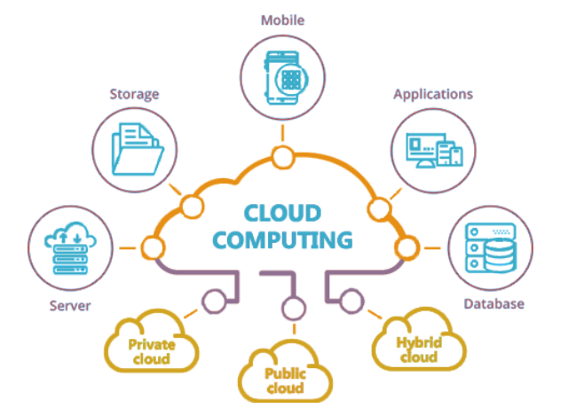

**Before cloud computing**

Before cloud computing came into the picture, the traditional business applications that were used were pretty complicated in their use and would typically cost a bomb. In addition to that, these systems need quite intensive support in terms of hardware and software, and it can prove to be quite daunting to begin with, especially if you are just starting out! This means that you would need an entire team of experts who would help you install, configure, run, test, secure, and update all of it. Imagine doing this for several apps. The efforts would have to multiply by that factor, which is probably why even the biggest companies with robust IT infrastructure fail to build the exact apps that they hope for. And if you are a small or medium-sized business, you probably don’t even have a chance. This is where cloud computing technology steps in to ease the burdens on business owners and users alike. However, we will get into the benefits of using cloud computing a little later.

**Cloud Architecture**

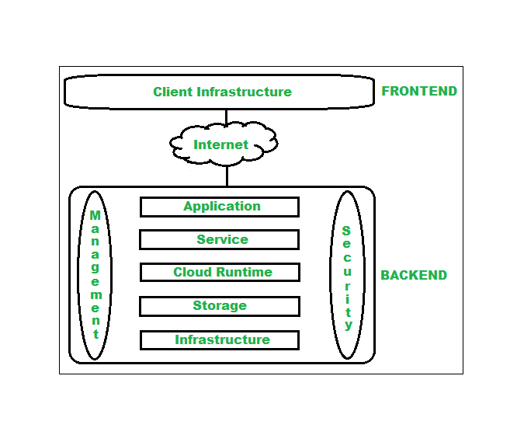

The cloud architecture is divided into 2 parts, i.e.,

1. Frontend

The frontend of the cloud architecture refers to the client side of the cloud computing system. This means it contains all the user interfaces and applications that are used by the client to access the cloud computing services and resources. For example, the use of a web browser to access the cloud platform.

Client Infrastructure: Client Infrastructure is a part of the frontend component. It contains the applications and user interfaces that are required to access the cloud platform. In other words, it provides a GUI (Graphical User Interface) to interact with the cloud.

2. Backend:

The backend refers to the cloud itself, which is used by the service provider. It contains the resources as well as manages the resources and provides security mechanisms. Along with this, it includes huge storage, virtual applications, virtual machines, traffic control mechanisms, deployment models, etc.

**Qualities of Cloud Computing:**

a) On-demand self-service: Each service provider can provide computer services such as e-mail, applications,   
network services, and storage services without the use of human intervention.   
b) Broad network access: The system's efficiencies can be linked by utilizing standard instruments that advance use by diverse thin or thick customers, for example, phones, tablets, portable workstations, or workstations.   
c) Resource pooling: resources such as storage, processing, and network capacity are examples of resources. By using a multi-tenancy model, the service providers can provide services based on customer demands irrespective of different real and practical resources that are attached and reattached dynamically.   
d) Rapid Elasticity: Provisioning efficiencies are greater and can be purchased at any time in any quantity based on consumer needs. e) Metered performance: It has been referred to as a pay-as-you-go pricing model.

**Deployment Models of Cloud Computing**

The deployment models of cloud computing describe who owns, manages, and is responsible for the services. These can be mainly categorized into four types, which are as follows:   
a) Public Cloud: In this model, a business provides administration and applications to the general public via a network of specialized cooperatives. It is also termed "external cloud". It is less secure.   
Examples include Amazon Web Services (AWS) and Microsoft Azure.   
b) Private Cloud: A private cloud gives a company access to systems and services that are only available to that company. It is also known as an "internal cloud." It offers greater security as a result of its private nature. Examples include Intel, Hewlett Packard (HP), and Microsoft, which have their own internal private clouds.   
c) Hybrid Cloud: This foundation is made up of at least two mists (public, private, or group) in which different elements are linked together by providing the benefits of different organizational models.   
d) Community Cloud: It provides access to frameworks and administration to a group of organizations. A framework can be shared between different associations inside a particular group, either hosted internally or externally.

**Types of Cloud Computing**

Every app developer, or app owner, must be aware of these three different kinds of cloud computing.

**IaaS (Infrastructure as a Service)**

IaaS contains the basic building blocks for cloud IT. It typically provides access to networking features, computers (virtual or on dedicated hardware), and data storage space. IaaS gives you the highest level of flexibility and management control over your IT resources. It is most similar to the existing IT resources with which many IT departments and developers are familiar.

**Platform as a Service (PaaS)**

PaaS removes the need for you to manage underlying infrastructure (usually hardware and operating systems) and allows you to focus on the deployment and management of your applications. This helps you be more efficient as you don't need to worry about resource procurement, capacity planning, software maintenance, patching, or any of the other undifferentiated heavy lifting involved in running your application.

**Software as a Service (SaaS)**

SaaS provides you with a complete product that is run and managed by the service provider. In most cases, people referring to SaaS are referring to end-user applications (such as web-based email). With a SaaS offering, you don’t have to think about how the service is maintained or how the underlying infrastructure is managed. You only need to think about how you will use that particular piece of software.

**Who is using cloud computing?**

Organizations of every type, size, and industry are using the cloud for a wide variety of use cases, such as data backup, disaster recovery, email, virtual desktops, software development and testing, big data analytics, and customer-facing web applications. For example, healthcare companies are using the cloud to develop more personalized treatments for patients. Financial services companies are using the cloud to power real-time fraud detection and prevention. And video game makers are using the cloud to deliver online games to millions of players around the world.

**Issues in Cloud Computing**

a) Security Issues: Security is a major concern for cloud computing. The security issues can be any combination of physical, operational, or programmatic security.

b) Data Issues: Data usage, backup, loss, integrity, and theft are examples of data issues.

c) Performance Issue: There may be a loss in the company’s revenue when there is poor performance related to applications. With the increasing number of resources in the cloud or in order to improve the application performance, administrators can use the scalability technique, where they can either do it vertically or horizontally based on the resource constraint.

d) Design Issues: Energy management, novel cloud architectures, and software licensing are examples of design issues.

e) Legal Issues: Examples of legal issues include the true location of your data, data responsibility, and intellectual property rights.

**Mobile cloud computing**

Mobile Cloud Computing (MCC) is an architectural approach that combines the processing power of mobile devices like smartphones or tablets with cloud-based resources. At its simplest, MCC refers to an infrastructure where both the data storage and data processing happen outside of the mobile device. Mobile cloud applications move the computing power and data storage away from the mobile devices and into powerful and centralized computing platforms located in clouds, which are then accessed over a wireless connection based on a thin native client.

**Architecture of MCC**

Base stations act as a medium between mobile devices and mobile networks. The base stations can be any combination of access points, satellites, or base transceiver stations. The physical characteristics of a base station are to establish and control the connections, and the functional characteristic is that it acts as an interface between mobile devices and mobile networks. All the information and requests by mobile users will be transmitted to the central processors with the help of base stations. These central processors are in turn connected to servers in a mobile network. Servers provide services on a mobile network. The services provided by mobile network

operators include verification, approval, and bookkeeping information in light of home operator and supporter's data. Subscribers’ requests were delivered to the cloud via the internet. Clouds consist of cloud controllers which process the solicitations to give the corresponding cloud services to the mobile users. These services were developed by using the concepts related to utility computing, virtualization, and SOA, i.e., service-oriented architecture.

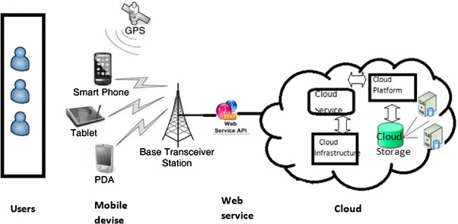

**Qualities of MCC**

a) Multi tenancy: The application is used to share the hardware resources, and how the users can influence the utilization of a single application and database to occur.

b) Scalability: Service providers can add or expand a service that allows mobile users to scale easily.

c)Availability: As we are using cloud computing technology, the services will be available to the users all the time, even when they are moving.

d) Reliability: When data or applications are stored in the cloud on mobile devices, there is less risk of data or application loss.

d) Dynamic Provisioning: Instead of requiring advance reservations, resources can be added dynamically on demand.

f) Ease of integration: With the help of cloud computing technology, many services from various specialist organizations can be coordinated to meet the versatile client's requests.

**MCC designs**

The MCC service models can be categorized in view of the parts and relations between the cell phones and the distributed computing elements. MCC makes use of cloud computing services such as platform-as-a-service (PaaS), infrastructure-as-a-service (IaaS), and software-as-a-service (SaaS). MCC services can be classified into three categories as follows

a) Mobile as a Service Consumer (MaaSC): This originated from the conventional client-server model with the help of virtualization, by employing access control mechanisms and cloud computing technology. In this type of service, mobile devices are the consumers of services.

b) Mobile as a Service Provider (MaaSP): A specialist co-op provides a cell phone component rather than a customer benefit in MaaSP.

c) MaaSB (Mobile as a Service Broker): Similar to MaaSP, MaaSB manages system administration and data transmission for other cell phones or detection hubs. In this model, the phone can also act as an entryway or intermediary, providing various benefits by utilizing various communication methods such as 3G, 4G, 5G, Bluetooth, and WIFI.

**Cloud App**

A cloud app or a mobile cloud app is an application that operates through the cloud and has a unique combination of characteristics from both pure desktop apps and pure web apps. This is a software programme where cloud-based and local components work together in a congruent manner.

**The defining characteristics of a cloud app may be listed as under:**

* Cloud infrastructure (a specific form of information architecture) is used to store data.
* Here, the data can be locally cached.
* There is scope for accommodating different user requirements in cloud app development.
* Cloud apps may be accessed from the desktop or mobile devices alike.
* Cloud Apps facilitate access to a whole new range of services.

**How do cloud apps work?**

At a remote data centre operated generally by a third-party, data is stored, and compute cycles are carried out. The uptime, integration, and security aspects are taken care of by a back end that also supports a multitude of access methods. Cloud applications are known for their responsiveness and the fact that they need not be permanently stored on the device. These apps can function quite well online, but they need to be updated in the online mode. Cloud apps can be placed under constant control, but they do not always occupy any storage space on a computer or communications device. Provided there is the availability of decent internet connectivity and the cloud app is written well, it is sure to offer the same experience as that of a desktop application while offering the portability of a web app.

**Difference between Mobile Cloud App and Native Mobile App**

As the world of mobile app technology is evolving rapidly, there are a great number of key decision points that new-age mobile app developers need to confront time and again. One of the key deciding points in choosing between mobile cloud apps and native mobile apps is the site where they may be stored.

A native mobile app is installed directly on a mobile device, and a separate version may be created for each of the mobile devices where the app would be used. It may either be pre-installed on the mobile device or be downloaded from an app store to be installed on the device.

Mobile cloud apps are quite similar to web-based applications, and the main similarity between the two is that they both run on external servers and need the use of a browser on the mobile device to display before giving way to the app's user interface.

A mobile cloud app does not need to be downloaded and installed on the device as the app UI can be viewed by the user by way of a browser window on the remote device. These apps need an internet connection to function.

**The distinctions between a cloud app and a web app**

* Web applications are almost entirely designed with the intent of being used from a web browser. Mobile cloud apps aren’t always completely dependent on web browsers to be able to function.
* The scalability of web applications is limited, whereas mobile cloud applications are inherently scalable.
* The user data and business processes for the web applications are stored in a single data centre, as opposed to cloud apps, where there are a number of replicated data centres.
* Web applications run only on the providers’ web servers, whereas cloud apps can run on the computing systems of the users in addition to the providers’ web servers.
* Each customer uses their own instance of the application in the case of web applications, whereas in the case of cloud apps, the provided application is fixed for each customer.
* While web applications are isolated-tenancy solutions, cloud apps are multi-tenancy solutions.

**Difference Between Cloud Computing & Mobile Computing**

Apart from the fact that both of these terms involve using wireless systems to transmit data, everything else is different.

* Cloud Computing affords a bridge between the client’s local or closed networks and their private data storage and backup systems. Mobile computing allows a barrage of functions, including accessing the internet through browsers, supporting multiple software applications with a core operating system, and exchanging a varied range of data types.
* Typically, mobile computing is more or less a consumer-facing service. Cloud computing, on the other hand, is something that is the preferred solution for a great number and variety of businesses and companies.
* Cloud computing is about designing new technologies and services that would allow wireless or hardwired data sharing over distributed networks. Mobile cloud computing pertains to the development of new hardware and interfaces.
* Cloud computing offers businesses the freedom to access services and functionalities that are as yet only accessible by way of wired connections. Mobile cloud services work with the intent of making the services available through various mobile network operators.
* Cloud computing assumes the role of an amalgamated entry point that lets users store and manage their files while being able to use an entire range of inherently advanced computing abilities. Mobile computing, however, focuses more on intelligent connectivity instead of focusing on virtual hosting and resource sharing.

**Best Practices for Mobile Cloud Computing Implementation**

**Access Management Solution and Deploy Identity**: Ensure solid access policies are in place to restrict accessibility and strengthen resources by enforcing least privilege rules. Privileged access should use session monitoring to audit and record access, ensuring privileges are role-based and the minimal access necessary to operate is granted. With a zero-trust model, access will be tightly controlled, needing every person, electronic device, or system to be cross-checked and validated before connecting to your network's systems or devices outside of the network perimeter.

**Secure Your Endpoint**: Coming up with new cloud computing projects isn’t always enough to ensure endpoint security is improved, as it’s indefinite. It can be beneficial to revisit existing security practices and confirm they are suitable for the new threats to get a start.

A standard defence-in-depth methodology incorporating firewalls, anti-malware, intrusion detection, and access control has been traditional for endpoint security. However, the impact of endpoint security considerations can be so complex that automation tools are necessary to stay abreast of the fashion. And in this case, endpoint detection and response (EDR) tools and endpoint protection platforms (EPP) can help resolve this issue.

Scan for vulnerabilities and misconfigurations and conduct security audits and testing to identify system vulnerabilities and possible security threats. Perform penetration testing of your network's environment (on-premises and cloud) to determine risks and vulnerabilities.

Create systematic processes to identify vulnerabilities in your system, and ensure your cloud vendor’s security processes are updated regularly to crack down on known vulnerabilities. Also, you should analyse post-patching effects to address any issues between systems and environments.

**Monitor user activity**: Analyse how cloud users use your business’s cloud environment. Evaluate your cloud users’ cloud culture as well. Casual use of data and data sharing could yield substantive personal data risks. For example, cloud computing enables users to retrieve, automatically archive, and transmit information from various sources. Soaring sharing could result not only in legitimate data leakages but additionally in data transmitted by non-authorized sources.

**Password Management**: Use these best practises for password management, including:

* Configure the minimum number of characters required for your password.
* Indicate the complexity requirements for passwords.
* Include a minimum of 10 previous passwords in the password history.
* Cancel existing passwords every ninety days, and set a security maximum password age and constant email alerts.
* To maintain a fresh set of local admin account passwords every month and yearly service account passwords, the administrator should reset them every 180 days.
* Tracking all password changes can aid with password auditing.
* To ensure consistent strong security at all levels, balance security concerns at different systems with an enterprise password management service.

**Compliance Management:** Compile alerts to select an audio-visual system so you can be notified when your organization may be out of compliance with applicable laws to avert untoward consequences.

Your company’s enterprise data ought to be protected by data encryption in effect at all times. Consider the extra use of several encryption services throughout your databases, servers, and networks.

When choosing your cloud computing service and company, make sure they have continuous security monitoring for each environment and all systems.

Review and adjust your cloud supplier’s platform-specific alerts and reports to locate and centralize your data from all connections and examine all environments at once to uncover a complete record of the computing environment’s security posture.

**The Advantages of Mobile Cloud Computing**

Mobile Cloud Computing provides more benefits for business clients than traditional desktop or server-based applications. The following are the benefits offered by mobile cloud computing:

**Cost-Effective** — Mobile cloud computing uses virtualized computing resources that the cloud providers can easily provide at much lower costs than hosting software on mobile devices. It saves the cost of maintenance and operation and hardware as clients tend to consume fewer power resources than their physical counterparts. Mobile Cloud Computing allows for flexibility in the usage of a device. The device can be easily and quickly switched from one application to another by using the cloud. We can use the same device to run different applications as required by the user or the aim of execution.

**Scalable**: Wireless cloud computing handles scalability automatically and without physical limitations by operating on cloud platforms.

**Affordable**: Mobile cloud computing allows for the sole use of a device to host the applications and services while ensuring that they are available at a specific location. With this, you can access it anywhere and have full control over your devices. Updates are also easy to provide as applications need only be hosted on the cloud server. And before the update, the device did not need any recertification.

**Faster execution**: Mobile cloud computing takes advantage of the capabilities of a single device or device group and utilizes them through web services. The selection of this application is faster due to the multitasking that occurs through spatial-visual processes. These benefits are more prominent for mobile devices with limited memory and processing power than for desktop or server-based computers.

**Challenges in Mobile Cloud Computing**

**A.** **Mobile Communication Issues**:

a) Low bandwidth is one of the major issues in MCC. The available bandwidth is distributed among various mobile devices. It’s three times slower when compared to wired networks.

b) Availability of services: it is a major threat to CC. There may be a network outage; mobile clients will be unable to connect to the cloud to obtain an administration due to movement congestion, and flag quality may be poor.

c) Heterogeneity: Dealing with wireless connectivity on heterogeneous networks can make it difficult to meet MCC requirements.

**B.** **Computer Problems**:

One of the fundamental highlights of MCC is calculation offloading. Offloading isn't generally successful in sparing vitality. It is basic to decide if to offload and which bits of the administration codes to offload. There are two sorts of offloading procedures

a) Offloading in a static environment

b) Offloading in a dynamic environment

**C. Security Issues:**

Security is the major concern for both mobile users and the data present in the cloud.

a) Cell phone security: Cell phones are susceptible to a wide range of security threats, including malicious code and helplessness. Cell phones coordinated with global positioning system (GPS) gadgets can cause protection issues for endorsers.

b) Cloud data security: While cloud computing technology benefits both mobile users and application developers, users and developers must exercise caution when dealing with data in terms of accuracy, verification, and advanced rights.

**D. Privacy Issues:**

Concerns about privacy Mobile users give their private data, which incorporates their present area. This turns into an issue when the enemy thinks about the users' delicate data.

**E. Alteration of Networks:**

The MCC should be perfect with various stages as the MCC is used as a part of various working framework-driven stages like Android, Apple iOS, and Windows Phone. The IRNA (Intelligent Radio Network Access) system deals with the execution of various versatile stage systems.

**Applications of Mobile Cloud Computing (Real World Examples)**

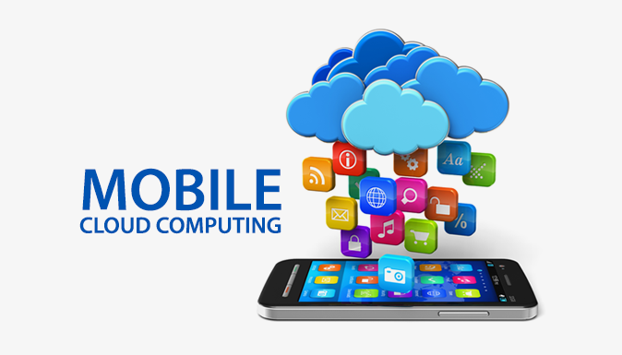

**Mobile-Email**This may drop some jaws, or at least cause some confusion when I say that Mobile Cloud Computing is applied to Mobile Email. It lets users view, manage, and respond to emails without accessing an office network.  
**Mobile-Sensing** By applying Mobile Computing, you can utilize smartphones that are equipped with various sensors and collect data from multiple apps on various compatible devices for various fields, including healthcare, social networking, environmental monitoring, and more!  
**Mobile-Healthcare**One of the most beneficial applications of mobile cloud computing is in the field of healthcare, and it minimizes the limitations of the traditional ways of doing it all. With this application, you can get access to these resources with great ease and efficiency. Using mobile cloud computing, you can store massive amounts of patient data in the cloud in real-time and enable services like:

* intelligent emergency management system.
* Pervasive lifestyle incentive management.
* Pervasive access to healthcare information
* Health-aware mobile devices
* comprehensive health monitoring services.
* Image viewing support
* Patient health record management systems

**Mobile-Gaming**Mobile Cloud Computing can be applied in the field of mobile gaming as it helps achieve scalability via scalable computation and instantaneous data updates on the cloud and on the mobile device. Thanks to the intelligent application of Mobile Cloud Computing, gamers only need to interact with the screen interface on their device without having to worry about any resources that may tie up their phones.

**Mobile-Social-Networking** With the help of this particular application of Mobile Cloud Computing, a group of mobile users can upload audio or video (multimedia) for real-time sharing. In this manner, you not only get great storage for data but also security for protecting the security and integrating the data.

**Location-Based-Mobile-Service** Applying Mobile Cloud Computing to Location-Based Mobile Services offers a solution to help and access information depending on the location. This is where the location trusted server takes care of the same. This may even let the user capture a small video clip of the buildings around them, all with the help of Mobile Cloud Computing.

**Mobile-Commerce**application of mobile cloud computing in mobile commerce for e-banking, e-advertising, and e-shopping by using scalable processing power. This way, you can measure the security while accommodating a high volume of traffic caused by a large number of users accessing it all at the same time.

**Multimedia-Sharing**This allows the sharing of multimedia information and gives a secure view of the stored information on the users’ smartphones. In this way, you get an administrative control that lets you manage the user access rights, which are needed to ensure security, a looming concern when it comes to mobile cloud computing. Using this application, people can easily share multimedia files, including photos and video clips, efficiently while being able to tag people they know on popular social networks like Twitter, Facebook, and other such platforms.

**Mobile-Learning:**Using Mobile Cloud Computing, it is possible to broaden the scope of m-learning applications by overcoming limitations such as slow or no network transmission speed, a scarcity of educational resources, and the high cost of devices. Using the cloud gives you a large storage capacity and powerful processing ability, thus ensuring that the users have at their disposal copious amounts of data with high processing speed and save on their device battery life. Mobile learning offers users access to learning materials on the cloud at anytime, anywhere.

**The Future of Mobile Cloud Computing**

Mobile Cloud Computing (MCC) is unique in its construct as it merges the rapidly growing cloud computing applications market with the omnipresent smartphone. The advantages of using mobile cloud computing have been acknowledged and appreciated by mobile users and cloud-based service providers.

It is the interface of MCC that has opened up the possibility and scope of incorporating videos, music files, images, and a lot more into this little omnipresent device called the smartphone. Some of the reasons why we claim that Mobile Cloud Computing is all set to become the future of mobile devices.

* **Longer battery life.**Since most of the processing is taken care of by the cloud, the battery usage of the mobile device is automatically brought down.
* **Large-Storage-Area:**This is the biggest highlight of mobile cloud computing – the huge amount of storage ability accessible to the mobile user. This means that the users do not have to worry at all about the kind of storage that is available on their phone or the storage requirement for the app to function.
* **Evolved techniques for synching data:**Using cloud storage, users have the ability to store and manage all their data with lightning quick synchronization between the mobile device and the desktop or any other device that the user chooses. This feature eliminates the need to create a backup and maintain it.
* **Improved Facilities for Processing** In general, it is the processor of the mobile device that determines the speed and its performance. But when it comes to Mobile Cloud Computing, a whole chunk of its processing is carried out at the cloud level. This in turn reduces the load on the device itself, thus improving the overall performance.
* **Exceptional User Experience**Unsurprisingly, mobile users stand to benefit the most from the use of mobile cloud computing. The platform has optimized productivity, which offers an improved user experience.
* **An Opportunity to Adopt New Technologies** Mobile Cloud Computing has an inherent capability to adapt to the dynamic and eternally evolving character of technology. Mobile cloud computing has the capability to perform efficiently with the latest upgrades in various methods of cloud computing and tweaks or other changes in the designs and features of the latest smartphones.
* **Current Trends in Mobile Cloud Computing**
  + Wearables that are cloud-connected
  + Vehicle-to-Vehicle Cloud Communication
  + The Internet of Things (IoT) is linked to the cloud.

**The Major Reasons Why Everybody Wants Cloud Mobile Applications**

By pushing mobile apps into the cloud, you only need to occupy minimal space on your user’s device, and the app can directly interact with the cloud for data transfer etc. While you are already aware of the myriad benefits the cloud has to offer, the following are the top 5 reasons why cloud mobile applications win big.

* No Need to Install the App
* Not Limited to a Specific Operating System or Device
* Cost Effective
* Maximum Data Security
* Easy integration with databases

**GROWTH OF THE MOBILE CLOUD MARKET**

* The mobile cloud market is expected to record a CAGR of 25.28% during the forecast period from 2022 to 2027. The cloud segment across the enterprises continues to make notable progress in environment-friendly innovations that meet consumer demand for a more sustainable community. There is a noticeable rise in awareness about high-performance mobile cloud platforms that have catered to the growing need across various end-user segments.
* The Asia-Pacific mobile cloud market is anticipated to expand significantly during the forecast period. It is expected that the private mobile cloud sector will soon continue to rule the market. Industry verticals like entertainment, utilities, education, healthcare, government, automotive, and industrials have dominated the mobile cloud market as these verticals are the major end users of mobile cloud.
* The growing adoption of cloud computing across the Asia-Pacific (APAC) region is driving a groundswell in demand for cloud networking services. In APAC, organizations across telecommunications, government, defence, financial services, manufacturing, and sovereign cloud providers have been the most receptive to adopting cloud networking.
* In Asia-Pacific, smartphone penetration, along with the rising utilization of online banking, is expected to drive the market in the region over the forecast period. Notably, a handful of companies are encouraged to bring their own devices (BYOD) policy, which may positively impact the integration of mobile cloud applications, thereby boosting the market's growth.
* With the mobile cloud, companies may utilize networking resources more effectively. The mobile cloud market will benefit industries by allowing them to use cloud computing for information technology optimization. Mobile networking hardware manufacturers such as 5G equipment makers and companies that provide mobile telephony software can package their products with mobile cloud data centre orchestration capabilities and offer them as complete solutions to CSPs in regional markets.
* However, the stringent regulations associated with BYOD by the government may discourage firms from implementing the technology within their organization, thus restraining the market growth in the region.

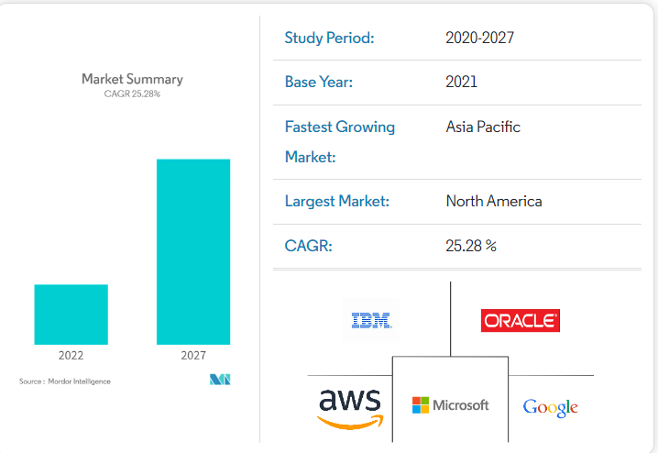

**RESEARCH AREAS IN MOBILE CLOUD COMPUTING**

Several research directions are moving in the development of MCC by dealing with different issues as exhibited in the segment. In any case, there are still a few disadvantages which should be tended to. This segment talks about a few open research issues bearing on the improvement of MCC. A portion of the test open research issues headings in versatile distributed computing are given beneath.

a) Latency b) Low Bandwidth c) Network Access Management d) Quality of Service e) Pricing f) Service Convergence g) Standard Interface h) Energy Efficiency i) Security and Privacy j) Better Service k) Task Division l) Data Delivery m) Mobility and Resource Discovery n) Mobility and Cloud Session Connectivity o) Overhead due to use of Cloud p) Reliability q) Scalability r) High Availability

**Conclusion**

MCC is an innovative approach to mobile computing that provides users with expanded capabilities and greater flexibility. Through MCC, users can take full advantage of the capacity of their smartphones or tablets by combining the processing power of these devices with that available in the cloud. Though the benefits of this technology are many, there are certain double-edged swords to not just be aware of, but also stay away from. This is still a technology that is in its nascent stage. The scope and potential of it all seem to be quite promising. The true path that it takes will be a little clearer when more and more companies begin adapting to it and investing in it. By following cloud security best practices and implementing the appropriate security tools, businesses can minimize risks and take full advantage of the benefits mobile cloud computing offers.

**REFERENCES**

 [1.] Challenging Issues and Limitations of Mobile Computing: DeepakGetal,Int.J.ComputerTechology&Applications,Vol 3 (1),177-181

[2.] http://en.wikipedia.org/wiki/Mobile_communication

[3.] <http://www.mobilecloudcomputingforum.com/>.

[4.] White Paper. Mobile Cloud Computing Solution Brief. AEPONA, 2010.

[5.] Christensen JH. Using RESTful web-services and cloud computing to create next generation mobile applications, In Proceedings of the 24th ACM SIGPLAN conference companion on Object oriented programming systems languages and applications(OOPSLA), 2009; 627–634.

[6.] Liu L, Moulic R, Shea D. Cloud service portal for mobile device management, In Proceedings of IEEE7th International Conference on e-Business Engineering(ICEBE), 2011; 474.

[7.] A Survey of Mobile Cloud Computing: Architecture, Applications, and Approaches Hoang T. Dinh, Chonho Lee, DusitNiyato, and Ping Wang

 [8.] Mobile Cloud Computing Service Models: A User Centric Approach JEEVAN J,RAMLING HALMANDGE,PUSHPALATHA S

 [9.] <http://www.slideshare.net/noumanashrafawan/mobile-cloud-computing-55534661>

[10.]https://aboutdigitalcertificate.wordpress.com/2014/03/10/5-top-challenges-in-mobile-cloud-computing-2/

[11.] https://en.wikipedia.org/wiki/Mobile_cloud_computing

[12.] Mobile Cloud Computing :A survey by Niroshinie Fernando, SengW.Loke, WennyRahayu [13.] Research on Mobile Cloud Computing: Review, Trend and Perspectives Han Qi, Abdullah Gani

[14.] http://www.sciencedirect.com/science/article/pii/S0167739X12001318

[15.]http://www.slideshare.net/GemsonGeorge/mobile-computing-and-applications-of-mobile-computing